**Experiment 3**

**Aim :** Perform an experiment on normalization.

**Description :** Normalization is used to scale the data of an attribute so that it falls in a smaller range, such as -1.0 to 1.0 or 0.0 to 1.0. It is generally useful for classification algorithms.

**Following normalization techniques are used:**

1. Decimal Scaling.

2. Min-Max Normalization.

3. z-Score Normalization.

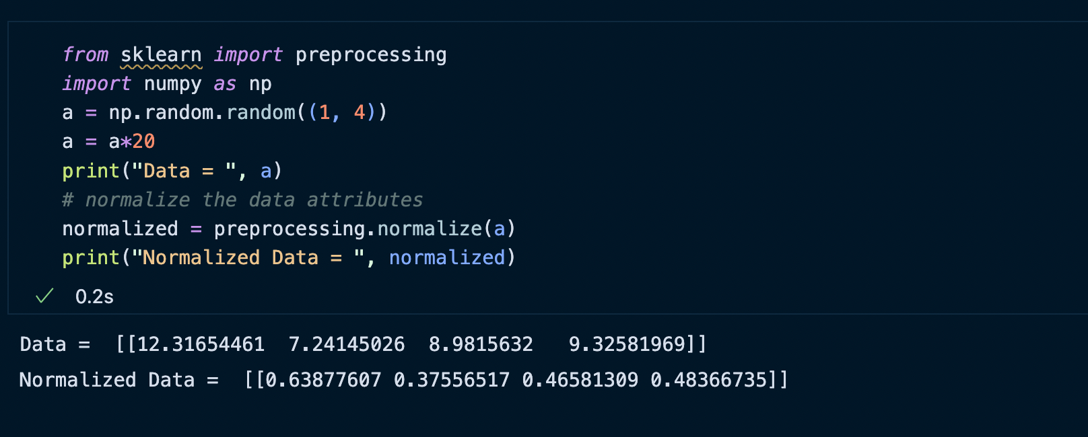

**Min-Max Scaling**

The min-max approach (often called normalization) rescales the feature to a hard and fast range of [0,1] by subtracting the minimum value of the feature then dividing by the range. We can apply the min-max scaling in Pandas using the .min() and .max() methods.

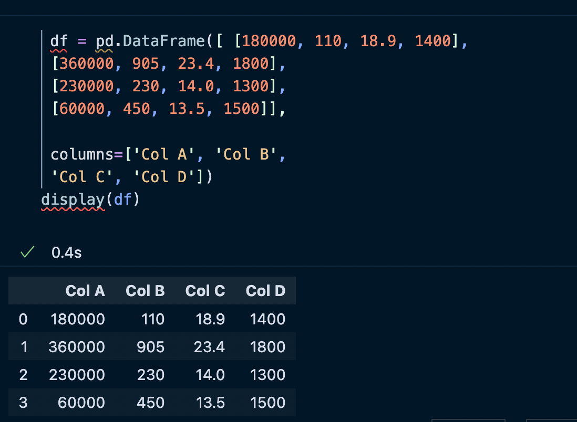

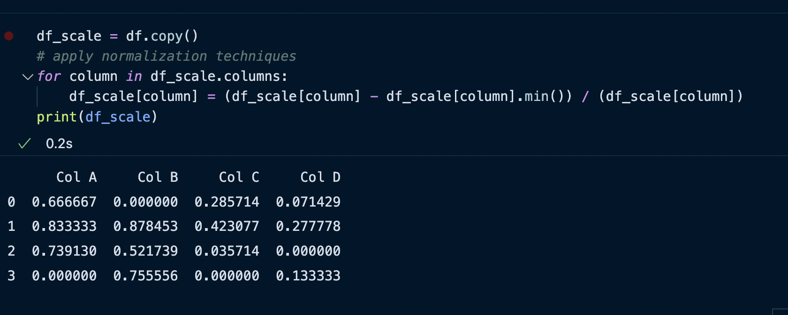

**The z-score method :**

The z-score method (often called standardization) transforms the info into distribution with a mean of 0 and a typical deviation of 1. Each standardized value is computed by subtracting the mean of the corresponding feature then dividing by the quality deviation.

